Project details

Sauce demo application -> shopping website

Action to be performed is as below

1. Login to website
2. Add the items to cart
3. Check out the items and finish the shopping
4. Verify the thanks you message

Tools used

Java, Maven, cucumber, Junit, TestNG annotations, Extend reports, POM

Project folder structure

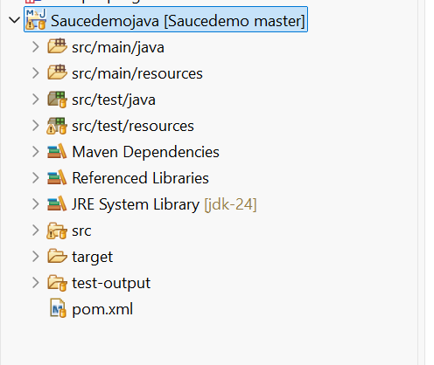

All the dependency are added in the POM. XML file

Created 3 packets

1. Pages
2. Step Definition files
3. Utilities
4. Feature file folder
5. Driver folder

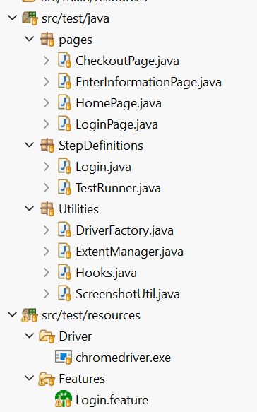

Feature file

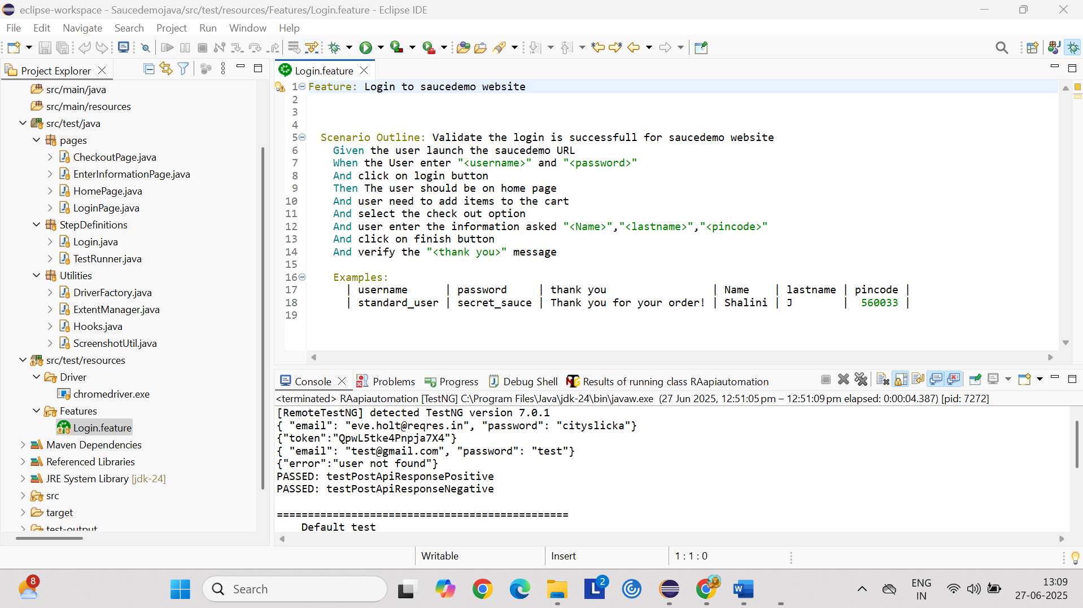

Step Definition implemented for above feature file

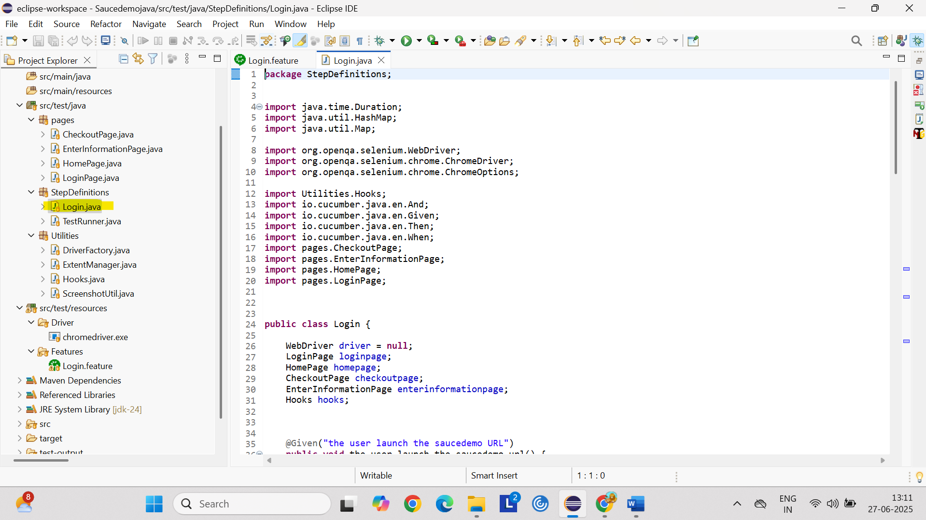

Utilities package have

4 class file all are related to Extend reports

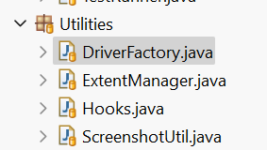

DriverFactory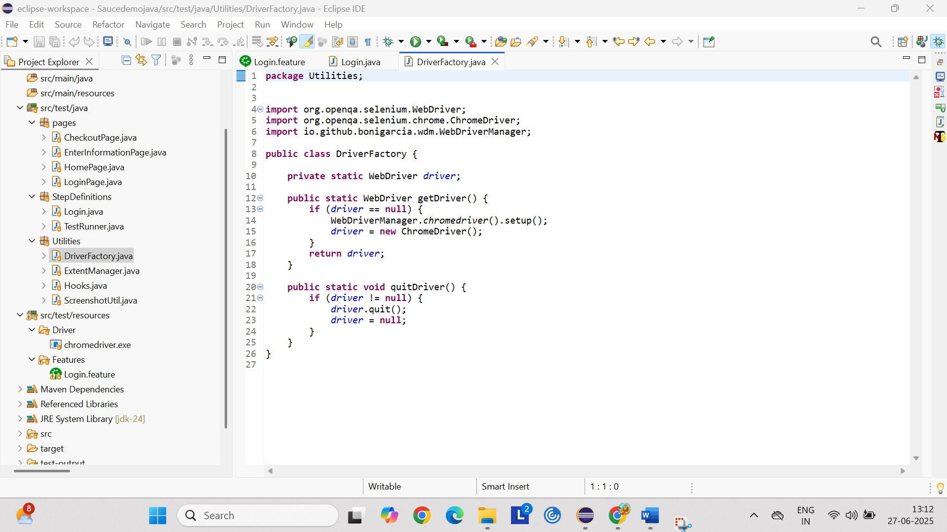

Extend manager

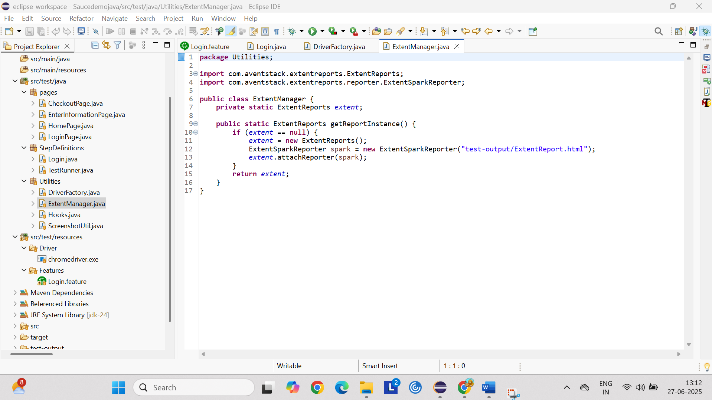

Hooks

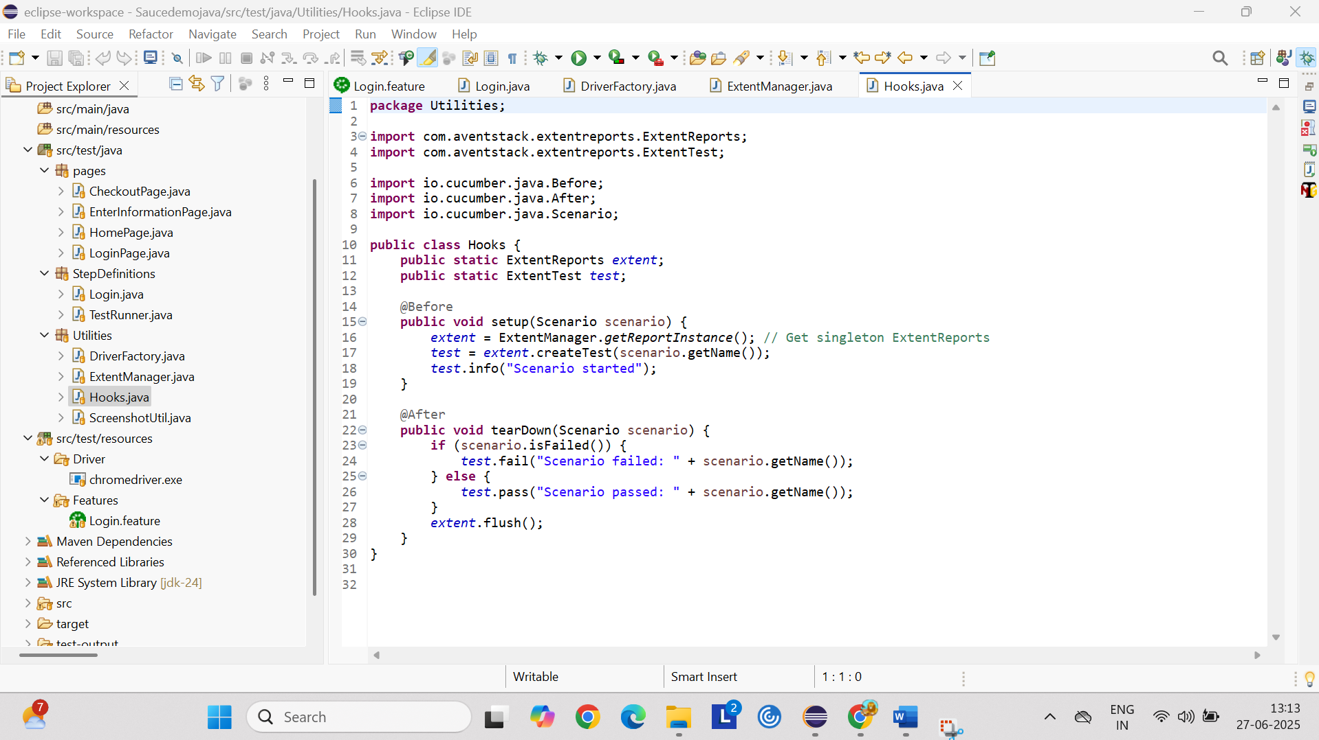

For screen shot

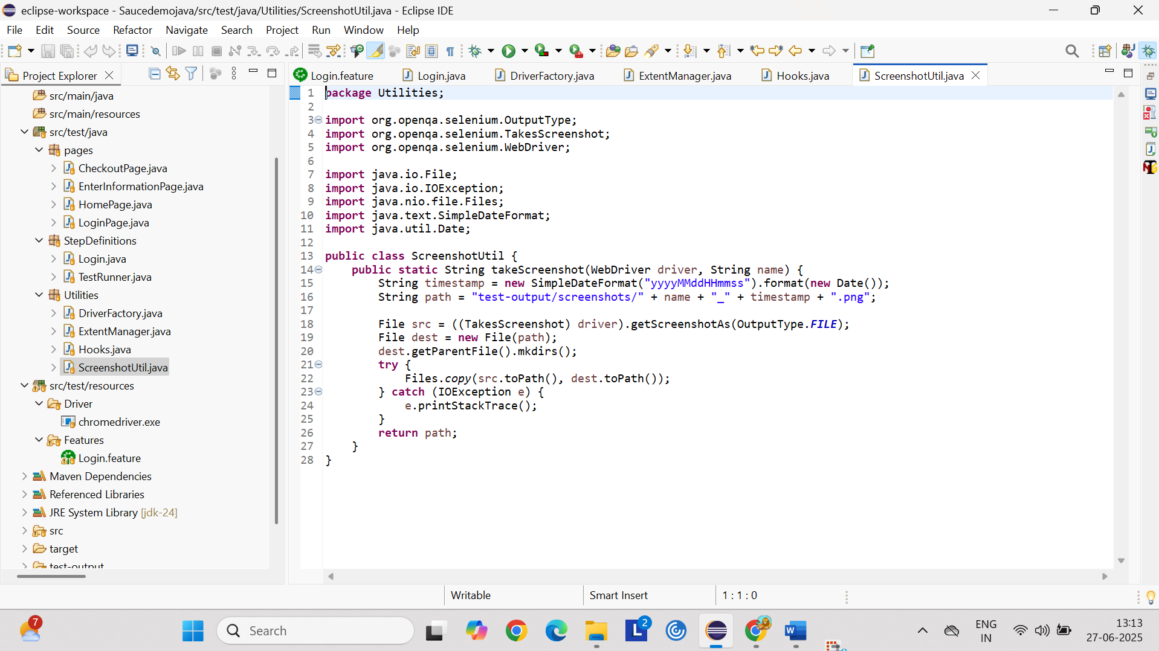

For Page object model

Created separate page for each page in the application

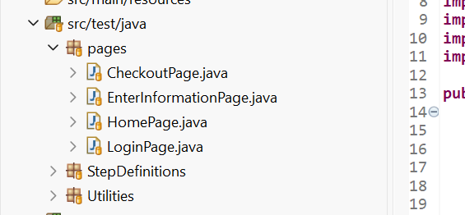

Login page with methods and login page locators

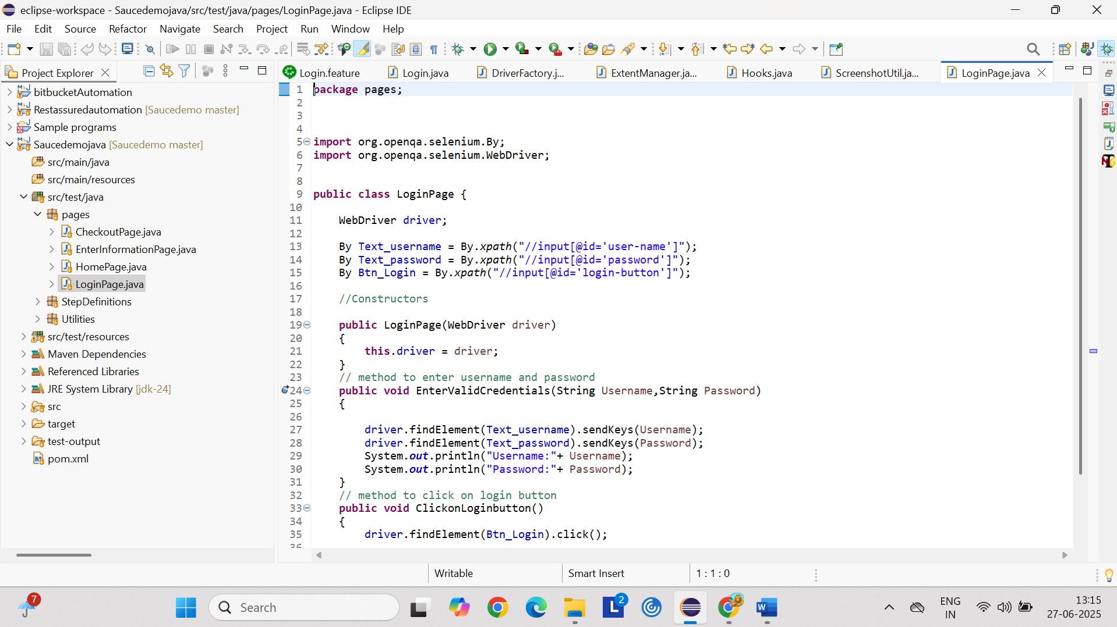

Home Page

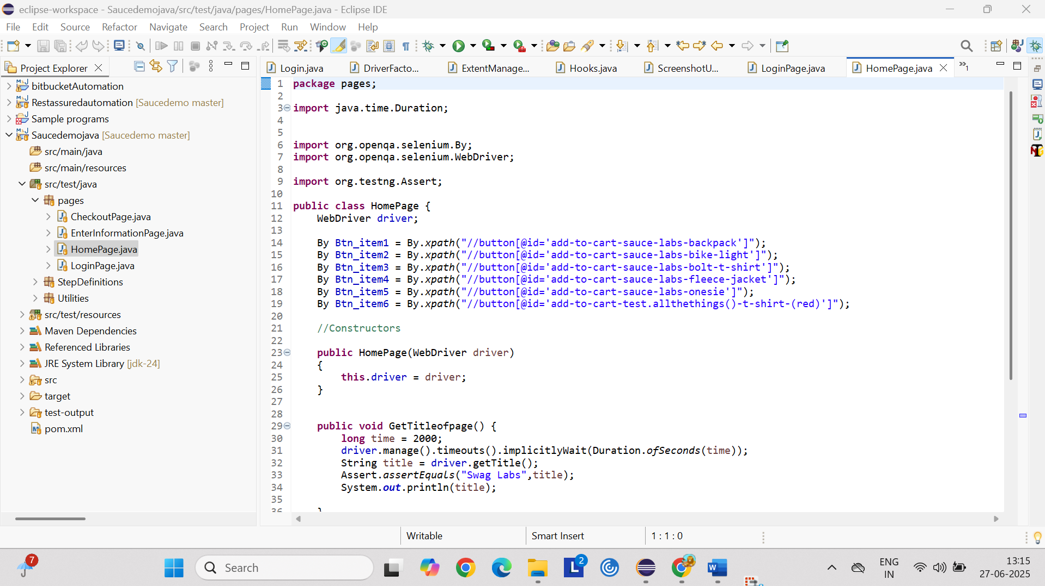

Check out page

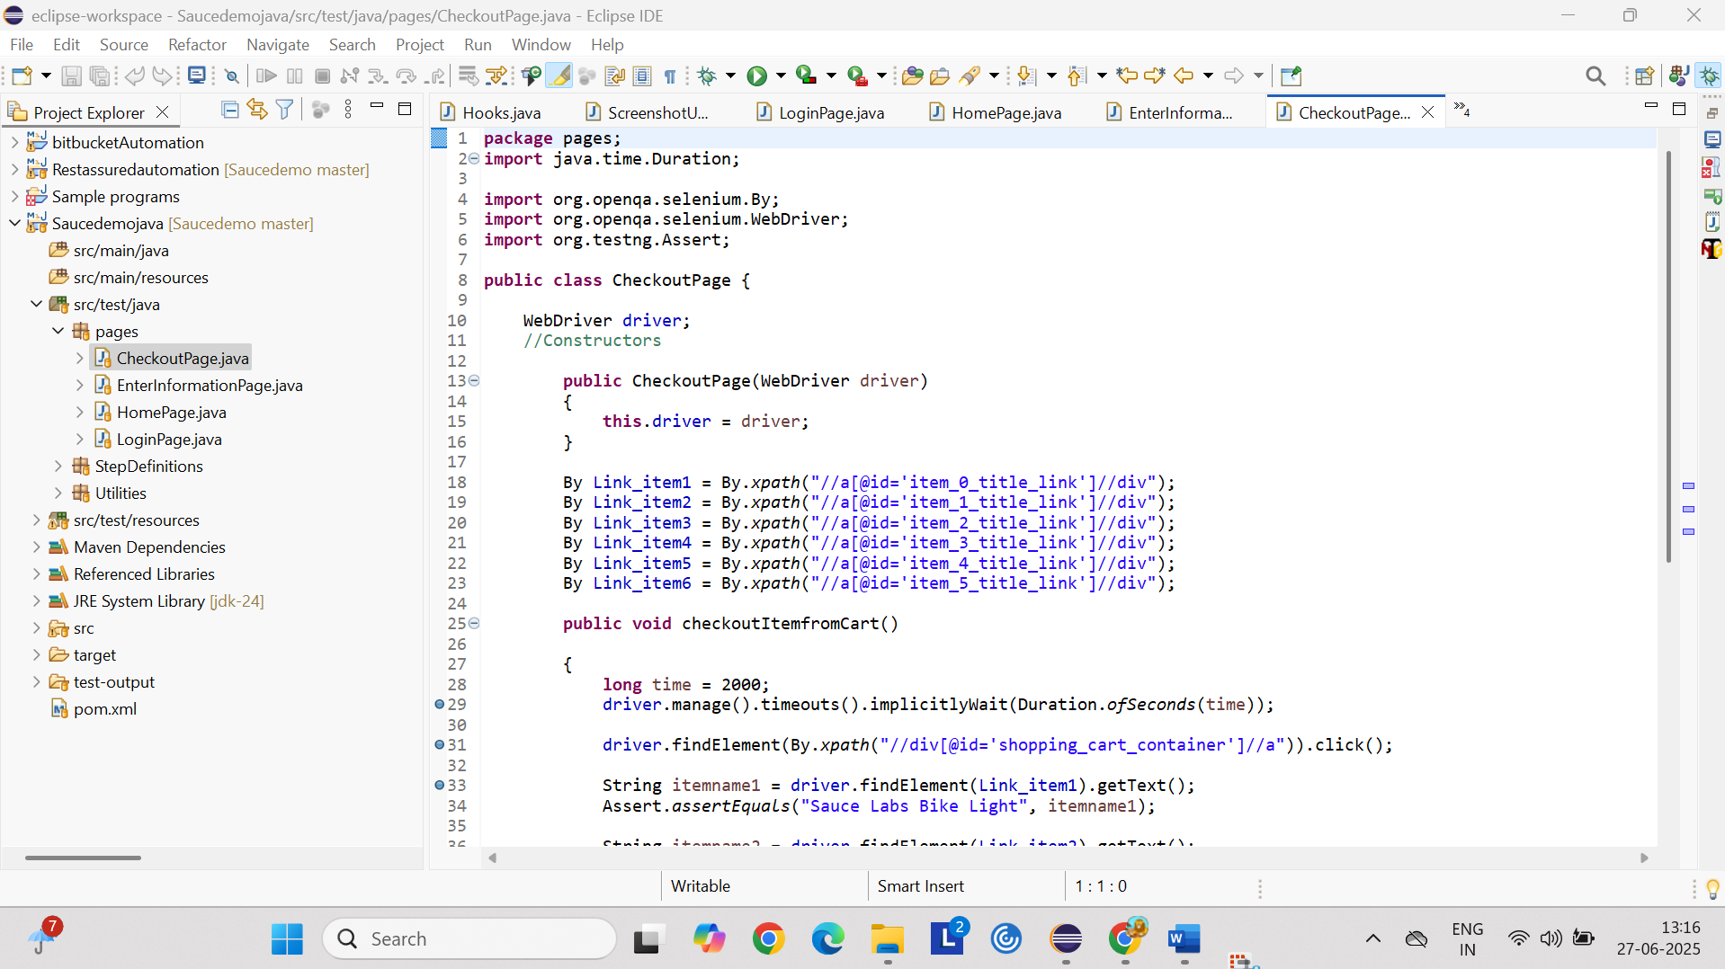

Enter information page

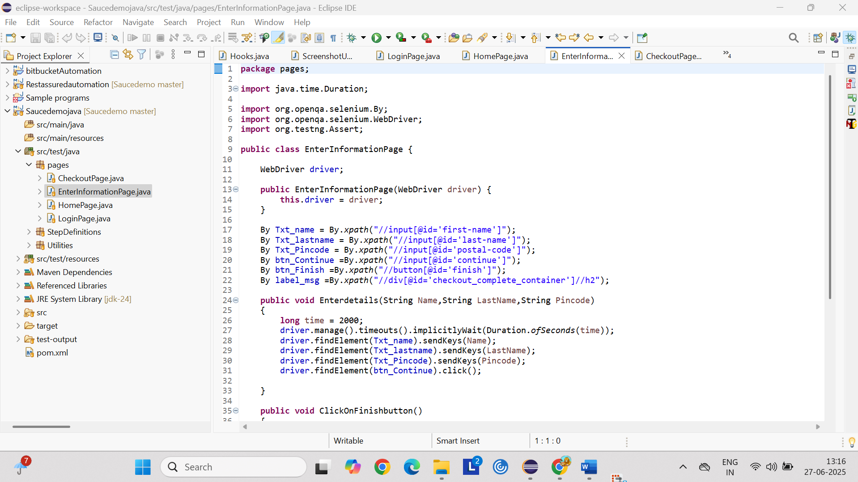

Test runner class with Junit

